Exercise 1.1: Search in Workday
Scenario
A guest speaker is coming to UNLV to speak to the Human Resource Department. It is for an annual lecture on Ethics and Conduct. Please create a requisition for a future date.
Step | Data to Enter or Select
- Type Create Requisition in the Search Bar and click Enter. | 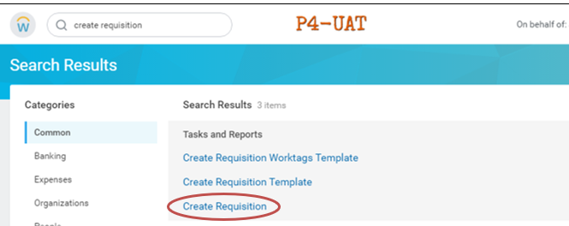
- Enter the appropriate Company if it is not yet filled out correctly  The user’s name should be in the Requester box, the user can change this if applicable. The person who is receiving the service should be in this field  Currency should be USD.  Select Guest Speaker from the Requisition Type drop-down box.  Then click OK in the bottom left corner. | 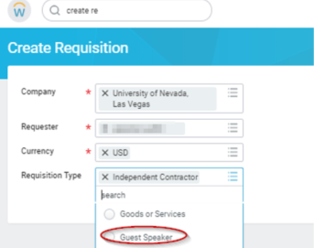
- On the next screen, click Request Non-Catalog Items. | 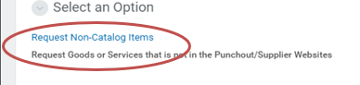
- Enter line items for services you want to purchase. Complete information for the service that you want to purchase  Non-Catalog Request Type*: Select Request Service  Description*: Provide description of the of the Service, including the business purpose of the guest speaker or Independent Service Provider.  Spend Category*:  Choose the SC0388 – Guest Speaker/ Lecturer for Guest Speaker  For an ISP or Independent Contract choose the appropriate Spend Category  Supplier: Type Supplier name click enter. It is best practice for the Supplier to be in the Workday system before creating a requisition.  Supplier Contract: Leave this Blank.  Start Date and End Date: Enter in expected Start Date and End Date for the service.  Extended Amount: Please enter the cost amount for the service.  Memo: Provide any internal notes in the Memo Box. | 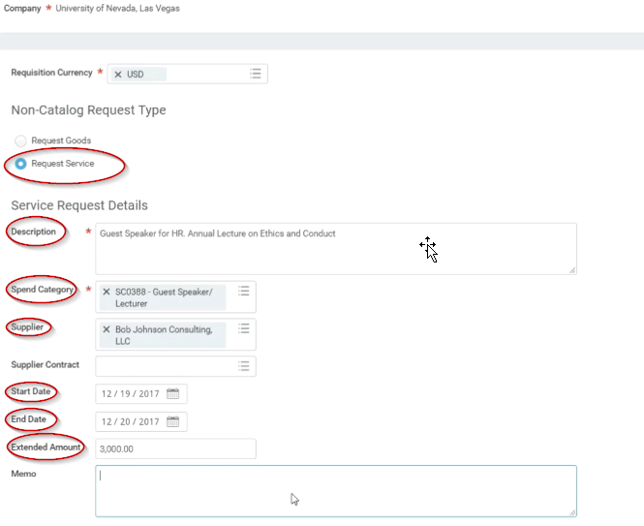
- Click Add to Cart . Then click OK .  You will then be taken to a blank screen to request additional items. | 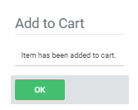
- Click the Shopping Cart Icon once all the line items are entered.
- The user can now view all the items in their shopping cart. They can edit the items if they need to here.
Click Checkout in the bottom left hand corner to create a requisition for the items and services in your cart.
- Review Shipping Address Tab:  Review the Shipping Address. The Ship To Address is defaulted to the address for the UNLV main campus. If you require a different Ship To Address (i.e. the services needs to be shipped to another campus), you can either select an address from the drop-down list by clicking on the side of the Default Ship To Address Box and selecting a Location or by selecting Use Alternate Address and entering in the address. Select Apply Ship To Address Changes to All Lines if you require the alternate Ship To address on all line items on the requisition.  Click Next . | 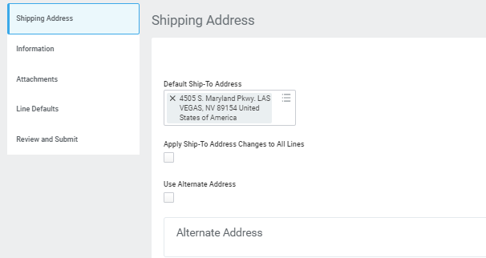
- Information Tab:  Requisition Type: Should be already filled in as Guest Speaker  Sourcing Buyer: Leave this blank.  High Priority: Leave this Blank  Memo to Suppliers: Leave this Blank  Internal Memo: If you have any internal comments for the requisition, you may include them here. Note here the name of Supplier and contact information if Supplier is not in Supplier Registration.  Click Next . | 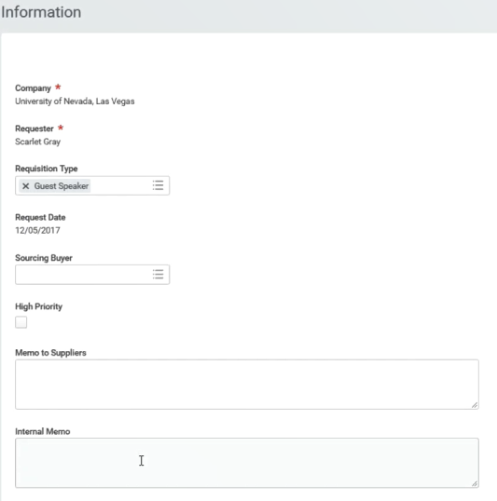
- Attachments Tab:  Add Attachments: You need to attach any quotes, agreements, terms and conditions or any other attachments associated with the purchase here. To attach a file you can either drop the file in the designated box or click Select files to select a file to attach.  Check External to include the attachments for your supplier. If you don't select this option, the attachments are available only to workers in your organization. When you create purchase orders from requisitions, Workday automatically includes external attachments from requisitions on the purchase order. Add comment to the attachment if needed.  Click Next . | 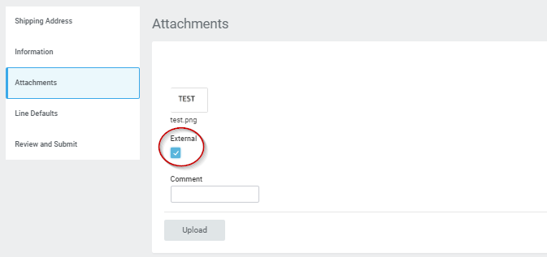
- Line Defaults Tab:  Requested Delivery Date: This may be left blank  Supplier: Make sure the Supplier is filled in here. (If this is NOT a guest speaker or independent contractor requisition type you may leave blank if Supplier is not registered yet or purchase will be subject to a formal RFP/Bid to be processed by the Purchasing Department)  RFQ Requirements: Leave this alone. The RFQ process is being handled outside of Workday.  Default Worktags and Splits: Choices are:  - Copy from Worktags Template: to copy from a set of commonly used worktags or split allocations. Use the Create Requisition Worktags Template task to create requisition worktags templates  - Use Default Worktags: DO NOT USE  - Use Default Splits: to default split allocations by percentage. The split allocation percentage defaults don’t apply to newly added requisition lines.  - None of the Above: Worktag details can be completed during the Review and Submit step (It is best to select None of the Above for this section until you gain better experience with Workday and Worktags.)  Click Next . | 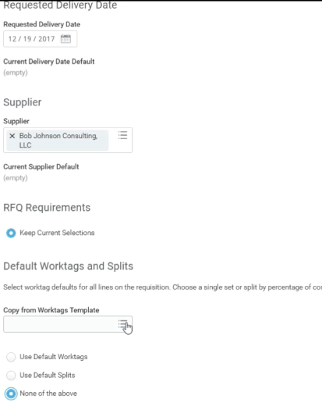
- Review and Submit Tab:  Review all goods and services on the requisition and add/change account information (Unit, Cost Center, Additional Worktags) that will be used for the purchase.  Leave the Fields Item and Supplier Contract blank.  You will need to delete out the default account information for Unit, Cost Center, and Additional Worktags and enter the correct Worktag information for the purchase. You can also split the cost of a line item between multiple Accounts.  Once all Worktag information for each line item is entered, Click Submit . | 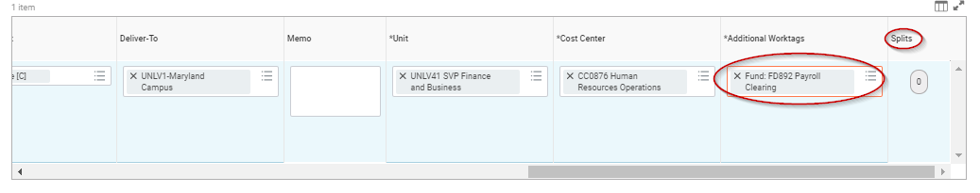  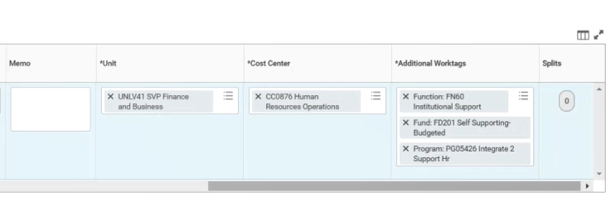  For this example you may use PG05426  TIP: Use this link to access the WAX tool! This will help you populate the worktags within Workday! You will input your OLD objects and it will map to your NEW objects in Workday  https://wax.unr.edu
Next Step: Find your Requisition | How do you go back and submit, edit, or review a requisition?  Run the Report from Workday Search Bar:  - My Requisitions
- Can you find your requisition?  What is the status of the requisition?  Where is the Edit Requisition button?  Can you see if there was a purchase order? | 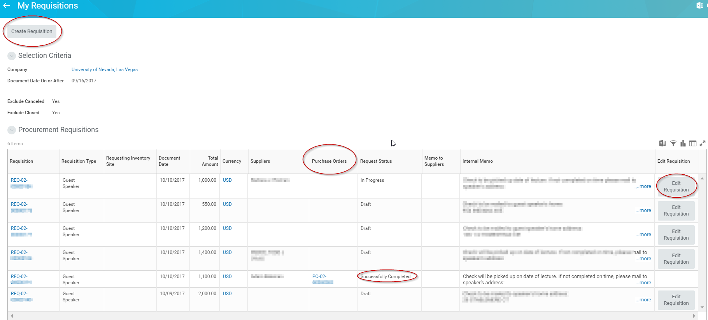
- Can you edit a Requisition in:
Draft? Yes
In Progress? Yes
Successfully Completed? No
Next Step: Create a Supplier Invoice Request
- Type in Create Supplier Invoice Request task in the Search Bar | 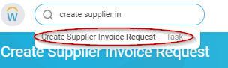
- In the Primary Information section fill out the required fields | 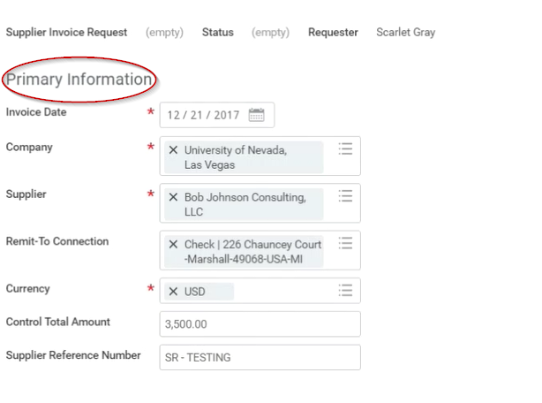
- Under the Additional Information section  Complete the field for Handling Code  Fill out Memo field here to reference the Purchase Order number from the requisition. | 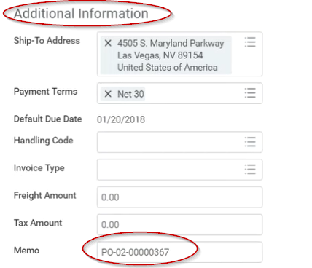
- Go to the Lines Tab and click the Service Line and complete the information for that service line for the ISP/Guest Speaker. | Item Description: Description of the service that the ISP or Guest Speaker (Guest Speaker for HR. Annual Lecture on Ethics and Conduct)  Spend Category: (Guest Speaker)  Extended Amount*: (3,500)  Unit Cost, Unit, Cost Center, Additional Worktags (Program, Gift, Grant, or Project) – fill out with WAX TOOL  Memo: (Work Order numbers) if applicable  Internal Memo: (Memo for the AP department) – (Supplier Remit to Address is different)  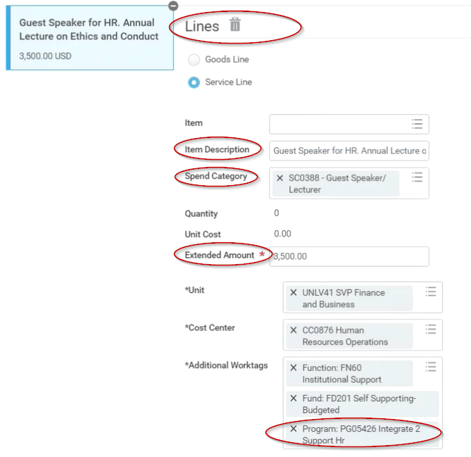
- Go to the Attachments Tab and add the Invoice | 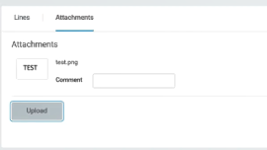
- Click Submit.

Notes:
Congratulations! You have completed this exercise.
End

